|  |  |
| --- | --- |
| **Vzdělávací materiál:** | **VY\_04\_SPU\_M1\_13** |
| **Název programu:** | **Operační program Vzdělávání pro konkurenceschopnost** |
| **Název projektu:** | **Lepší start** |
| **Registrační číslo projektu:** | **CZ.1.07/1.2.17/02.0037** |
| ***Předmět:*** | **Matematika** |
| ***Stupeň:*** | **první** |
| ***Téma – učivo:*** | **Počítáme do deseti. Sčítání.** |
| ***Autor:*** | **Mgr. Lenka Zemánková** |
| ***Citace:*** | Klipart Office Microsoft |

*Cvičení 1 (****VY\_04\_SPU\_M1\_13):***

MC900229357[1] Počítej nahlas, dopiš číslici, vypočítej, řekni odpověď.

C:\Users\HP_2\AppData\Local\Microsoft\Windows\Temporary Internet Files\Content.IE5\GRHCT81Y\MC900425954[1].wmfC:\Users\HP_2\AppData\Local\Microsoft\Windows\Temporary Internet Files\Content.IE5\GRHCT81Y\MC900359571[1].wmfC:\Users\HP_2\AppData\Local\Microsoft\Windows\Temporary Internet Files\Content.IE5\GRHCT81Y\MC900425954[1].wmfC:\Users\HP_2\AppData\Local\Microsoft\Windows\Temporary Internet Files\Content.IE5\GRHCT81Y\MC900425954[1].wmfC:\Users\HP_2\AppData\Local\Microsoft\Windows\Temporary Internet Files\Content.IE5\GRHCT81Y\MC900359571[1].wmfC:\Users\HP_2\AppData\Local\Microsoft\Windows\Temporary Internet Files\Content.IE5\GRHCT81Y\MC900425954[1].wmfC:\Users\HP_2\AppData\Local\Microsoft\Windows\Temporary Internet Files\Content.IE5\GRHCT81Y\MC900359571[1].wmfC:\Users\HP_2\AppData\Local\Microsoft\Windows\Temporary Internet Files\Content.IE5\GRHCT81Y\MC900425954[1].wmf

Hrušek je \_\_\_\_\_\_ . Jablíček je \_\_\_\_\_\_\_\_\_ .

Kolik ovoce je celkem?

|  |  |  |  |  |
| --- | --- | --- | --- | --- |
|  | **+** |  | = |  |

*Cvičení 2 (****VY\_04\_SPU\_M1\_13):***

MC900229357[1]Počítej:

Jan má C:\Users\HP_2\AppData\Local\Microsoft\Windows\Temporary Internet Files\Content.IE5\JWMT9ZDN\MC900426056[1].wmfC:\Users\HP_2\AppData\Local\Microsoft\Windows\Temporary Internet Files\Content.IE5\JWMT9ZDN\MC900426056[1].wmfC:\Users\HP_2\AppData\Local\Microsoft\Windows\Temporary Internet Files\Content.IE5\JWMT9ZDN\MC900426056[1].wmfC:\Users\HP_2\AppData\Local\Microsoft\Windows\Temporary Internet Files\Content.IE5\JWMT9ZDN\MC900426056[1].wmfC:\Users\HP_2\AppData\Local\Microsoft\Windows\Temporary Internet Files\Content.IE5\JWMT9ZDN\MC900426056[1].wmfC:\Users\HP_2\AppData\Local\Microsoft\Windows\Temporary Internet Files\Content.IE5\JWMT9ZDN\MC900426056[1].wmf.

Petr má C:\Users\HP_2\AppData\Local\Microsoft\Windows\Temporary Internet Files\Content.IE5\GRHCT81Y\MC900398511[1].wmf C:\Users\HP_2\AppData\Local\Microsoft\Windows\Temporary Internet Files\Content.IE5\GRHCT81Y\MC900398511[1].wmf C:\Users\HP_2\AppData\Local\Microsoft\Windows\Temporary Internet Files\Content.IE5\GRHCT81Y\MC900398511[1].wmf.

|  |  |  |  |  |
| --- | --- | --- | --- | --- |
|  |  |  |  |  |

Dohromady mají \_\_\_\_\_ aut.

*Cvičení 3 (****VY\_04\_SPU\_M1\_13):***

MC900229357[1] Pracuj podle návodu:

|  |  |
| --- | --- |
| C:\Users\HP_2\AppData\Local\Microsoft\Windows\Temporary Internet Files\Content.IE5\JWMT9ZDN\MC900030734[1].wmfC:\Users\HP_2\AppData\Local\Microsoft\Windows\Temporary Internet Files\Content.IE5\JWMT9ZDN\MC900030734[1].wmfC:\Users\HP_2\AppData\Local\Microsoft\Windows\Temporary Internet Files\Content.IE5\JWMT9ZDN\MC900030734[1].wmfC:\Users\HP_2\AppData\Local\Microsoft\Windows\Temporary Internet Files\Content.IE5\JWMT9ZDN\MC900030734[1].wmfC:\Users\HP_2\AppData\Local\Microsoft\Windows\Temporary Internet Files\Content.IE5\JWMT9ZDN\MC900030734[1].wmfC:\Users\HP_2\AppData\Local\Microsoft\Windows\Temporary Internet Files\Content.IE5\GRHCT81Y\MC900398511[1].wmf | 5 + 1 = 6 |
| C:\Users\HP_2\AppData\Local\Microsoft\Windows\Temporary Internet Files\Content.IE5\FS2M24WB\MC900389406[2].wmfC:\Users\HP_2\AppData\Local\Microsoft\Windows\Temporary Internet Files\Content.IE5\FS2M24WB\MC900389406[2].wmfC:\Users\HP_2\AppData\Local\Microsoft\Windows\Temporary Internet Files\Content.IE5\FS2M24WB\MC900389406[2].wmfC:\Users\HP_2\AppData\Local\Microsoft\Windows\Temporary Internet Files\Content.IE5\FS2M24WB\MC900389406[2].wmfC:\Users\HP_2\AppData\Local\Microsoft\Windows\Temporary Internet Files\Content.IE5\FS2M24WB\MC900389406[2].wmfC:\Users\HP_2\AppData\Local\Microsoft\Windows\Temporary Internet Files\Content.IE5\FS2M24WB\MC900389406[2].wmfC:\Users\HP_2\AppData\Local\Microsoft\Windows\Temporary Internet Files\Content.IE5\GRHCT81Y\MC900432223[1].wmf | . + . = . |
| C:\Users\HP_2\AppData\Local\Microsoft\Windows\Temporary Internet Files\Content.IE5\VKA0BKMP\MC900438139[1].wmfC:\Users\HP_2\AppData\Local\Microsoft\Windows\Temporary Internet Files\Content.IE5\VKA0BKMP\MC900438139[1].wmfC:\Users\HP_2\AppData\Local\Microsoft\Windows\Temporary Internet Files\Content.IE5\VKA0BKMP\MC900438139[1].wmfC:\Users\HP_2\AppData\Local\Microsoft\Windows\Temporary Internet Files\Content.IE5\VKA0BKMP\MC900438139[1].wmfC:\Users\HP_2\AppData\Local\Microsoft\Windows\Temporary Internet Files\Content.IE5\VKA0BKMP\MC900438139[1].wmfC:\Users\HP_2\AppData\Local\Microsoft\Windows\Temporary Internet Files\Content.IE5\VKA0BKMP\MC900438139[1].wmfC:\Users\HP_2\AppData\Local\Microsoft\Windows\Temporary Internet Files\Content.IE5\VKA0BKMP\MC900438139[1].wmfC:\Users\HP_2\AppData\Local\Microsoft\Windows\Temporary Internet Files\Content.IE5\FS2M24WB\MC900438133[1].wmf | . + . = . |
| C:\Users\HP_2\AppData\Local\Microsoft\Windows\Temporary Internet Files\Content.IE5\FS2M24WB\MC900398569[2].wmfC:\Users\HP_2\AppData\Local\Microsoft\Windows\Temporary Internet Files\Content.IE5\FS2M24WB\MC900398569[2].wmfC:\Users\HP_2\AppData\Local\Microsoft\Windows\Temporary Internet Files\Content.IE5\FS2M24WB\MC900398569[2].wmfC:\Users\HP_2\AppData\Local\Microsoft\Windows\Temporary Internet Files\Content.IE5\FS2M24WB\MC900398569[2].wmfC:\Users\HP_2\AppData\Local\Microsoft\Windows\Temporary Internet Files\Content.IE5\FS2M24WB\MC900398569[2].wmfC:\Users\HP_2\AppData\Local\Microsoft\Windows\Temporary Internet Files\Content.IE5\FS2M24WB\MC900398569[2].wmfC:\Users\HP_2\AppData\Local\Microsoft\Windows\Temporary Internet Files\Content.IE5\FS2M24WB\MC900398569[2].wmfC:\Users\HP_2\AppData\Local\Microsoft\Windows\Temporary Internet Files\Content.IE5\FS2M24WB\MC900398569[2].wmfC:\Users\HP_2\AppData\Local\Microsoft\Windows\Temporary Internet Files\Content.IE5\JWMT9ZDN\MC900436255[1].png | . + . = . |
| C:\Users\HP_2\AppData\Local\Microsoft\Windows\Temporary Internet Files\Content.IE5\JWMT9ZDN\MC900311114[1].wmfC:\Users\HP_2\AppData\Local\Microsoft\Windows\Temporary Internet Files\Content.IE5\JWMT9ZDN\MC900311114[1].wmfC:\Users\HP_2\AppData\Local\Microsoft\Windows\Temporary Internet Files\Content.IE5\JWMT9ZDN\MC900311114[1].wmfC:\Users\HP_2\AppData\Local\Microsoft\Windows\Temporary Internet Files\Content.IE5\JWMT9ZDN\MC900311114[1].wmfC:\Users\HP_2\AppData\Local\Microsoft\Windows\Temporary Internet Files\Content.IE5\JWMT9ZDN\MC900311114[1].wmfC:\Users\HP_2\AppData\Local\Microsoft\Windows\Temporary Internet Files\Content.IE5\JWMT9ZDN\MC900311114[1].wmfC:\Users\HP_2\AppData\Local\Microsoft\Windows\Temporary Internet Files\Content.IE5\JWMT9ZDN\MC900311114[1].wmfC:\Users\HP_2\AppData\Local\Microsoft\Windows\Temporary Internet Files\Content.IE5\JWMT9ZDN\MC900311114[1].wmfC:\Users\HP_2\AppData\Local\Microsoft\Windows\Temporary Internet Files\Content.IE5\JWMT9ZDN\MC900311114[1].wmfC:\Users\HP_2\AppData\Local\Microsoft\Windows\Temporary Internet Files\Content.IE5\VKA0BKMP\MC900428143[1].wmf | . + . = . |

*Cvičení 4 (****VY\_04\_SPU\_M1\_13):***

MC900229357[1] Přepiš a vypočítej:

3 + 3 \_\_\_\_\_\_\_\_\_\_\_\_\_\_\_\_\_\_ 2 + 6 \_\_\_\_\_\_\_\_\_\_\_\_\_\_\_\_

2 + 5 \_\_\_\_\_\_\_\_\_\_\_\_\_\_\_\_\_\_ 1 + 7 \_\_\_\_\_\_\_\_\_\_\_\_\_\_\_\_

5 + 3 \_\_\_\_\_\_\_\_\_\_\_\_\_\_\_\_\_\_ 6 + 2 \_\_\_\_\_\_\_\_\_\_\_\_\_\_\_\_

9 + 1 \_\_\_\_\_\_\_\_\_\_\_\_\_\_\_\_\_\_ 6 + 4 \_\_\_\_\_\_\_\_\_\_\_\_\_\_\_\_

*Cvičení 5 (****VY\_04\_SPU\_M1\_13):***

MC900229357[1]Vypočítej hada:

***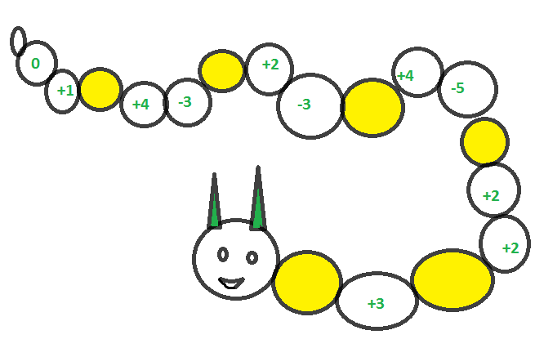***

*Cvičení 6 (****VY\_04\_SPU\_M1\_13):***

MC900229357[1]Zjisti, které číslo od 1 do 10 chybí, zapiš je do prázdného trojúhelníku. Vypočítej potom příklady a spoj se správnými výsledky.

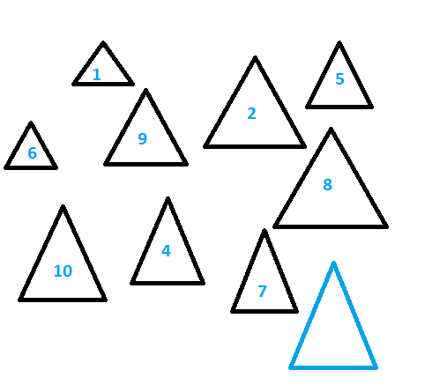

3 + 5 6 + 2 6 + 3 5 + 1

2 + 5 8 + 2 9 + 1 1 + 7

1 + 0 2 + 1 2 + 2 3 + 4

7 + 2 1 + 1 3 + 1 5 + 1

4 + 4 2 + 8 7 + 3 2 + 7